**Procedure related to 3130/3130xl Computer Name Changes... Read & understand ENTIRE procedure FIRST!**

**A) Pre-condition:** [*Log on to computer using a User Account with Administrative privileges.*]

1. Ideally, make an image of the existing computer configuration so that you can easily revert to the existing state should this process go drastically wrong.
2. Locate the installation disks (including registration codes) for any of the software that will be un-installed.
3. Locate the following files; the file names appear in multiple locations, so ensure that you find the ones in this EXACT path:
   1. E:\AppliedBiosystems\UDC\Tools\Oracle\product\11.1.0\db_1\network\**admin**\tnsnames.ora
   2. E:\AppliedBiosystems\UDC\Tools\ Oracle\product\11.1.0\db_1\network \**admin**\listener.ora
4. Backup your Data Collection software license files (see E:\AppliedBiosystems\UDC\Data Collection\bin\config\licenses)
   1. If more than one license exists in the folder, backup the most current version and delete the remaining copies from the folder.
   2. Backup the following file: lifetech-licensing.properties
5. Backup (export) desired user-defined features in Sequencing Analysis and GeneMapper.
   1. templates and Projects
   2. Analysis module settings
6. As an extra precaution, backup Run data from the E: drive data folder.
7. As an extra precaution, open Data Collection (DC) and backup user-defined features (in Module Manager, Protocol Manager [Instrument protocols; Analysis protocols]) from DC.
8. Turn off any software co-installed with DC v.4.0 (e.g. SeqA, SeqScape, GeneMapper); uninstall as shown:
   1. Caution: During this process, computer shutdowns and restarts may run for what appear to be abnormally long times; be PATIENT and let the computer shutdown and restart normally... do NOT power-off the computer to force a shutdown.
   2. Data Collection **MUST** be running (at least first 2 services of *Service Console*) when you uninstall SeqA or GeneMapper; see note on *Service Console* image.

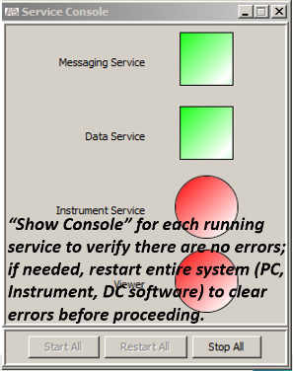

* 1. Uninstall each application one at a time (**Control panel>Programs and Features**); **ideally**, in between each uninstall operation, shut down DC and restart computer (restarting first two services of DC software).
  2. When un-installing software, there is a slight chance the process will corrupt your profile (files and folders located in C:\Users\user_name)... such that you are re-directed to a TEMP profile upon logging into the computer. If so, do an internet search for “computer logging into temp profile” and correct the problem; one good source is [Fix-temporary-profile-windows-7](http://www.sysprobs.com/fix-temporary-profile-windows-7).
  3. Ignore any message about uninstalling “Auto-Analysis”.
  4. Verify that file **Sequencing Analysis Software 6 Resources** was deleted by opening the following folder, **C:\AppliedBiosystems\SeqA** (Note: there are two **C:\AppliedBiosystems** folders); the file should not exist anymore, if you have uninstalled SeqA properly.

1. After uninstalling SeqA and/or GeneMapper, close all Applications and reboot the computer.

**B) Computer Name change Procedure:**

1. Computer Name Change.
   1. Make certain that all Data Collection services remain off.
   2. Use a pathway similar to: **START>Settings>Control Panel>System** to navigate to the Computer Name tab of System Properties window. You should see a window similar to the following:

System Properties panel for changing Computer Name

* 1. Select ‘Change’ to bring up the screen that allows for editing the computer name:
     1. New computer name: If changing the name, edit the name, but leave the Workgroup name as is; select “Ok”.
        1. When system asks you if you wish to reboot computer now, say “No, do not reboot computer”
        2. Do NOT launch Data Collection at this point.
     2. Same computer name: If the computer name has already been changed, simply ‘select’ the current name and save it in a text file; the name will be required for a later step. Leave workgroup name alone, and select ‘Cancel’.

1. Select My Computer icon and right-click mouse button:
   1. Select “Manage” from popup menu items
   2. Stop the following two Oracle services (refer to the following screenshot):
      1. OracleUDCTNSListener
      2. OracleServiceUDC
   3. Exit “Computer Management” application.

Computer Management panel showing Oracle Services to turn off

1. Modify two (2) Oracle files:
   1. The two files (tnsmanes.ora; listner.ora) are located in the following pathways:
      1. E:\AppliedBiosystems\UDC\Tools\Oracle\product\11.1.0\db_1\network\**admin**\listener.ora

E:\AppliedBiosystems\UDC\Tools\ Oracle\product\11.1.0\db_1\network \**admin**\tnsnames.ora

* + 1. CAUTION: If the pathway is not exactly as seen above, search computer for listener.ora and tnsnames.ora files. There are multiple copies of these files on your hard drive; the files that need to be modified are in an ‘**admin**’ folder.
  1. Open these files in Wordpad.
     1. Change the host name only; the host name appears once in “listener.ora” and twice in “tnsnames.ora”.
     2. Do NOT add any spaces or empty lines
     3. Save both files to their original paths.

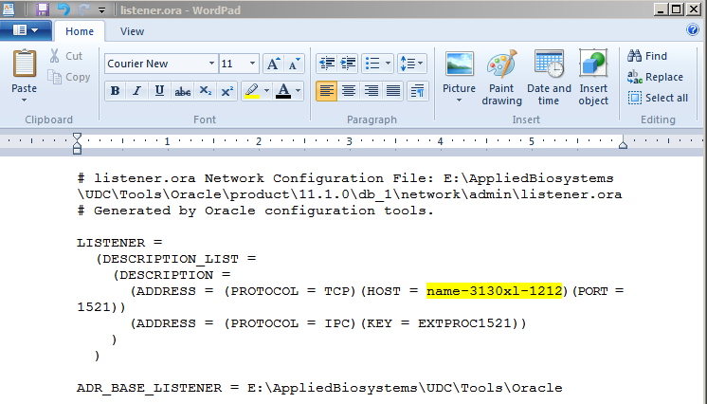

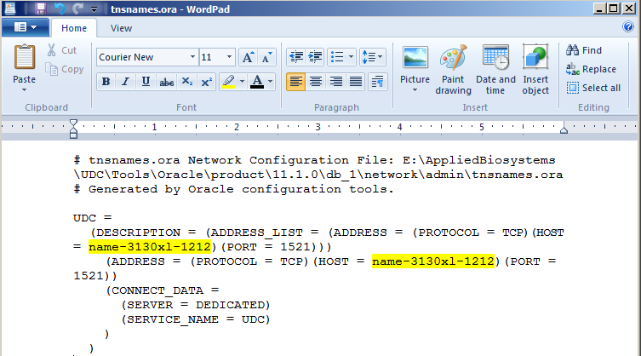

1. Remove the Data Collection software license key file
   1. Locate the following directory: E:\AppliedBiosystems\UDC\DataCollection\bin\config\licenses
   2. If you did not backup the license file already (see Preconditions), do so now.
   3. Ensure that all license files have been deleted from that directory, but leave the following file: lifetech-licensing.properties
2. Re-install DC software license
   1. Close all running applications and reboot computer.
   2. Launch the Data Collection software.
   3. You will be prompted to re-enter the Data Collection licenses file/key. (If computer is not rebooted, then the first DC launch will fail at Data Service.)
   4. Once DC fully launches, close it down.
3. At this point, the modifications to the new image are complete.
   1. Launch Data collection to confirm system functionality (DC will still show original computer name).
   2. Ensure that computer name has been changed (Control Panel >System) on the computer itself.

**C) Reinstall Software:**

1. Reinstall Sequence Analysis software.
   1. Stop the 3rd and 4th Consoles in the Data Service, leaving ONLY the first two services of the Data Collection software **running.**

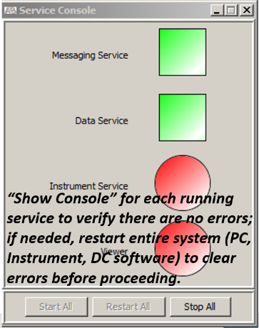

* 1. Install the Sequence Analysis software.
     1. If your system was set up in a 32-bit configuration (as recommended), the software will notify you that there are less than 4 GB of memory available; say “yes” to continue.
     2. Leave Data Service console on, despite warning to close apps.
  2. Launch Sequencing Analysis software and enter registration code.
  3. Import your original Analysis parameters (etc.).
  4. Close both Data Collection and Sequencing Analysis software.
  5. Restart computer.
  6. Relaunch both DC and SeqA to ensure you can create new plate records and analyze files.

1. Reinstall GeneMapper software.
   1. Stop the 3rd and 4th Consoles in the Data Service, leaving ONLY the first two services of the Data Collection software running.



* 1. Install the GeneMapper software.
  2. Launch GeneMapper and enter the registration code (new computer name should appear in GeneMapper).
  3. Close both Data Collection and GeneMapper.
  4. Restart the computer.
  5. Relaunch Data Collection and GeneMapper.
     1. To create Fragment Analysis Plate Records in DC, you will need to add at least one Panel through **Tools>Panel Manager**; once done, you can select either that Panel or “None” when creating a plate record.
     2. Result Groups: Reinstallation of GeneMapper generates a new GeneMapper identification number for plate records; this, causes all existing Fragment Analysis Results Groups in Data Collection to convert to “generic” GeneMapper and they will not appear in new plate record templates.
        1. Create a new FA Results Group in DC; export *.xml files for new FA Results Group and for all existing FA Results Groups.
        2. Open new *.xml file in software capable of editing *.xml files (e.g., Notepad++); copy new GeneMapper identification number.
        3. Open the other *.xml files, and replace the two instances of the old identification number in each file with the new number; save all files.
        4. Delete existing FA Results Groups from Data Collection; import edited *.xml files. (Note: Results Groups cannot be deleted if associated with files; either remove the files by DC’s **Database Manager>Cleanup Processed Plates** function... or edit the Results Group Owner value in the *.xml file.)
  6. Create a new FA Plate Record in DC to verify access to all edited FA Results Groups.

Example of *.xml file (FA Results Group) opened in Notepad++; copy the new number at locations ‘1’ and ‘2’ and paste it in place of the old number in the *.xml files you need to edit (note, in the image, the number and the results group owner have been blacked out).

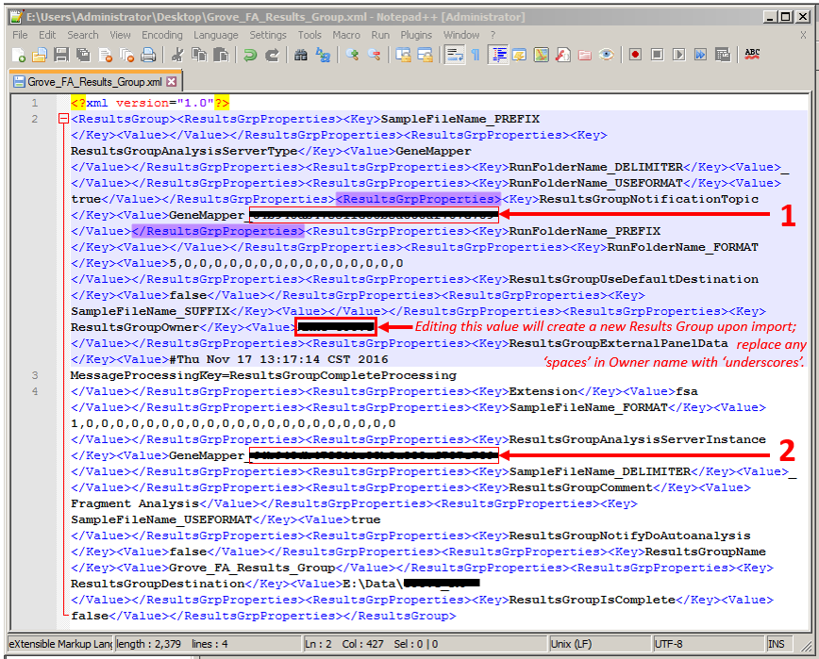

**D) 3130xl Instrument ID**: (*Paragraph below was updated on 18 March 2020; no changes to actual procedure.*)

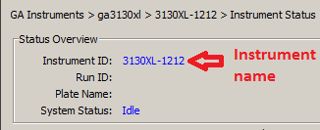

With the ABI 3130xl Genetic Analyzer, there is a “**Computer Name**” and an “**Instrument ID**”; at this point, these will be different even though all the ABI software (include Data Collection) will be imprinted with the new computer name. The Instrument Rename utility is supposed to let you convert the Instrument ID to the new Computer Name; however, every time I ran the utility, it created some “identification” issues.

It is possible that the problems were related to a file that the utility could not find on our computer (E:\AppliedBiosystems\Service\JRE\bin\hotspot\JVM.dll), but I was never able to get confirmation of that idea or any resolution of the issue from ThermoFisher. Anyway, I ultimately just left the ‘name’ and ‘ID’ as different... and there were no adverse effects from doing so. Nevertheless, perhaps this was just an issue on our machines; thus, I am providing the protocol below for your consideration.

1. Re-name **Instrument** in Data Collection:
   1. Obtain a zipped copy of the following file from ThermoFisher support: InstrumentRename.exe
   2. Shutdown all Data Collection services in Service Console, and then close the Service Console.
   3. Create a new folder on your E:drive, and extract InstrumentRename.exe to that new folder.
      1. Note: File extension may have been changed (from *.zip) to prevent deletion of this executable file by email systems.
      2. If necessary, restore the *.zip extension before attempting the extract the file.
   4. Double-Click on InstrumentRename.exe to start its execution.
   5. Edit the pop-up window as needed’:
      1. Input the new computer name in “New Instrument Name”; and,
      2. Retain existing Serial # (4 digits, a dash, and 3 digits; e.g, 2345-001).

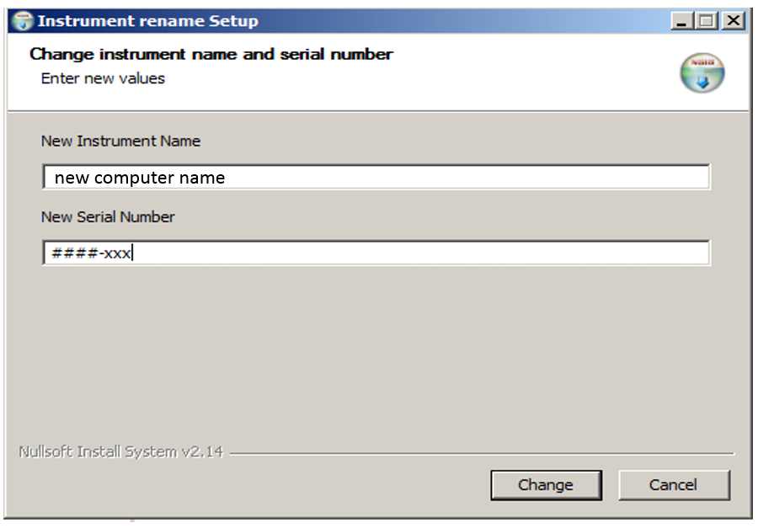

* 1. Click ‘Change’.
  2. Several black DOS CMD windows will appear while the utility is running. The utility needs to start and stop JBoss during the re-naming sequence. This process may take ~1-3 minutes to run. If a window pops up, stating failed to connect to 127.0.0.1 – port 8082 multiple times, ignore the message. You might also see a message that a ‘specified module’ could not be found; click ‘ok’ to let the process continue.

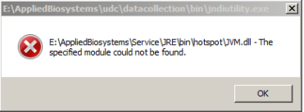

* 1. Once windows stop opening up, you will have an FMQServer window with the last line which reads ‘Redirecting output to Log files’. The Instrument rename Setup will state that the setup was successful. At this point, you can select the ‘close’ button, and a window will pop-up confirming that the instrument name change was successful.

1. Reboot the computer and start DC, SeqA, and GeneMapper to verify that all work correctly.